
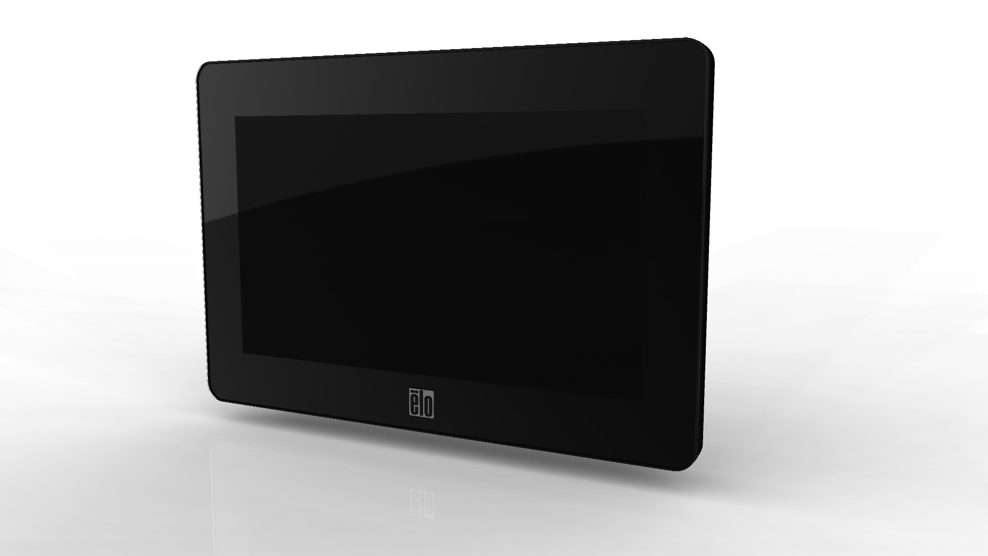
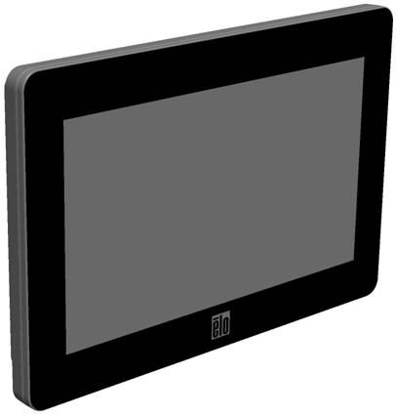

User Manual
Touchmonitor 0700L
Copyright © 2015 Elo Touch Solutions, Inc. All Rights Reserved.

No part of this publication may be reproduced, transmitted, transcribed, stored in a retrieval system, or translated into any language or computer language, in any form or by any means, including, but not limited to, electronic, magnetic, optical, chemical, manual, or otherwise without prior written permission of Elo Touch Solutions, Inc.

Disclaimer

The information in this document is subject to change without notice. Elo Touch Solutions, Inc. and its Affiliates (collectively "Elo") makes no representations or warranties with respect to the contents herein, and specifically disclaims any implied warranties of merchantability or fitness for a particular purpose. Elo reserves the right to revise this publication and to make changes from time to time in the content hereof without obligation of Elo to notify any person of such revisions or changes.

Trademark Acknowledgments

AccuTouch, CarrollTouch, Elo, Elo (logo), Elo Touch, Elo Touch Solutions, IntelliTouch, iTouch, SecureTouch, TouchTools and VuPoint are trademarks of Elo and its Affiliates. Windows is a trademark of Microsoft Corporation.
Table of Contents

Chapter 1 - Introduction 4

Chapter 2 – Installation 5

Chapter 3 – Mounting 8

Chapter 4 – Operation 9

Chapter 5 – Technical Support 10

Chapter 6 – Safety & Maintenance 11

Chapter 7 – Regulatory Information 12

Chapter 8 – Warranty Information 15
Chapter 1 - Introduction

Product Description
Your new touchmonitor combines Elo Touch Solutions’ reliable performance with the latest developments in touch technology and display design. This combination of features creates a natural flow of information between a user and the touchmonitor.

This touchmonitor incorporates a 24-bit color, active matrix thin-film-transistor LCD panel to provide high quality display performance. Its WVGA resolution of 800x480 is suitable for displaying graphics and images. Its LED backlight significantly reduces power consumption and eliminates mercury (compared to CCFL-backlit panels). Other features that enhance this LCD monitor’s performance are power/video/touch over one USB cable, an optional magnetic strip reader (MSR), and an optional webcam.

Precautions
Follow all warnings, precautions and maintenance as recommended in this user manual to maximize the life of your unit and prevent risks to user safety. See the Safety & Maintenance chapter for more information.

This manual contains information that is important for the proper setup and maintenance of the unit. Before setting up and powering on your new touchmonitor, read through this manual, especially the Installation, Mounting, and Operation chapters.
Chapter 2 –Installation

Unpacking the Touchmonitor
Open the carton and verify the following items are present:
- Touchmonitor with protective sheet for its face
- User Manuals CD
- Quick Install Guide
- Japanese language regulatory information pamphlet
- USB Y-cable (Black: Power and USB signal, Red: additional Power)

Minimum Computer Hardware Requirements
- 2.0GHz Dual Core CPU
- 512MB of RAM. More if other applications are to run at the same time.
- 2 USB 2.0 port
- 30MB of free disk space
- CD-ROM drive or network access for software downloads

Connector Panel & Interfaces

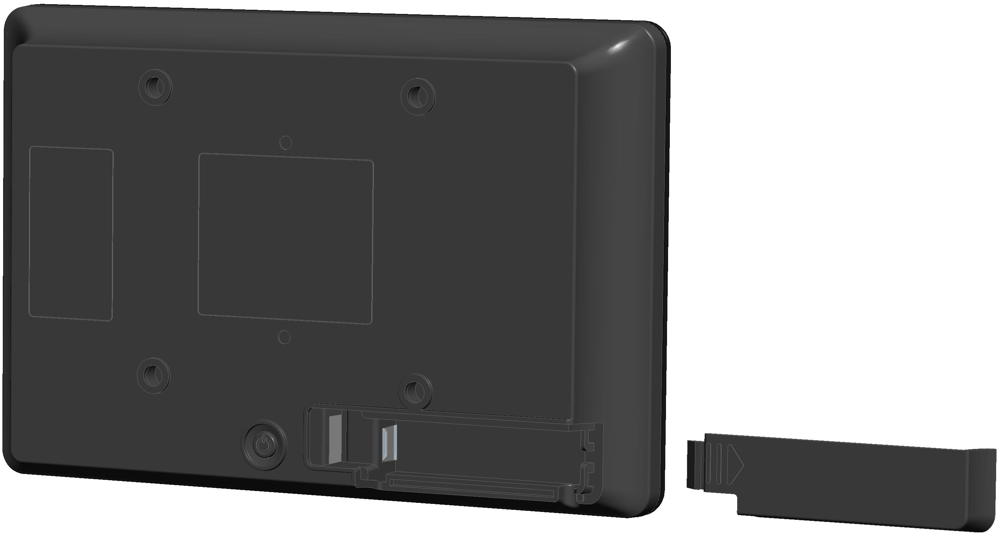
Mini USB
.

Touchmonitor Connections
1. Connect the USB cable between the monitor’s Mini USB connector & your PC’s USB port. It is recommended that you plug in both USB to your PC, in the order of red USB then black USB.
2. The touchmonitor ships in an ON state, video should be displayed on your monitor already.

Installing the DisplayLink Software Drivers
The DisplayLink technology enables video-over-USB. It allows your monitor to use one USB cable for power, video and touch.

The drivers for the Windows 7, XP 32-bit (SP2, SP3), Vista 32-bit (SP1), and Vista 64-bit (SP1) operating systems are available on the Elo Touch Solutions website.
Installing the Touch Technology Software Drivers

Some software installation is required for your touchmonitor to work with your computer.

The drivers for the Windows 7, XP, Vista, WePOS, and 32-bit Server 2003 and 2008 operating systems are available on the Elo Touch Solutions website.

Visit the www.elotouch.com for:
- The most up-to-date touch driver versions
- Additional touch driver information
- Detailed touch driver installation guides
- Touch drivers for other operating systems

Chapter 3 – Mounting

Rear VESA Mount
A four-hole 75x75mm mounting pattern for M4 screws is provided on the rear of the monitor. The VESA FDMI-compliant counting is coded: VESA MIS-D, 75, C

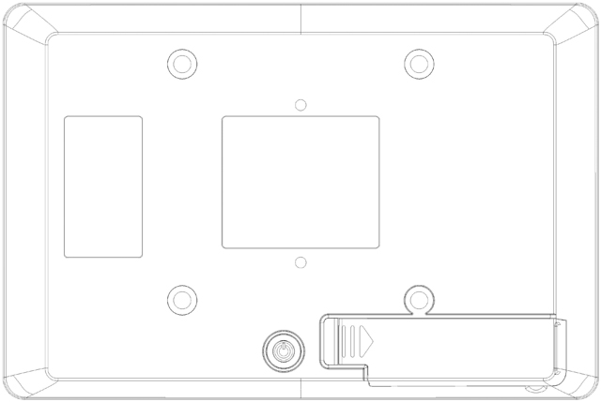
75mm
75mm

Chapter 4 – Operation
Power
To turn the touchmonitor on or off, press the touchmonitor power button once.

The system consumes low power when in SLEEP and OFF modes. For detailed power consumption specifications, refer to technical specifications on the Elo website http://www.elotouch.com

Touching the screen will bring the attached host PC out of SLEEP mode (similar to moving the mouse or pressing a keyboard key).

Video
A display’s native resolution is its width and height measured in number of pixels. Generally, for best performance, an image displayed on this monitor will look best when your computer’s output resolution matches this monitor’s native resolution of 800x480.

In Extend Mode, the monitor extends the desktop of the primary display. The resolutions of the monitor and the primary display are maintained.

In Mirror mode, the monitor duplicates the desktop of the primary display. In this mode, the output resolution of the monitor and the primary display must be the same. Therefore, the resolution of the monitor and the primary display may be changed to a lower resolution. If the monitor resolution is different from the primary display’s resolution, then the resolution will be changed so that the whole desktop on the primary display fits in the monitor, and that the primary display’s aspect ratio is maintained.

Chapter 5 – Technical Support

If you are experiencing trouble with your touchmonitor, refer to the following suggestions.
If the problem persists, please contact your local dealer or contact Elo Touch Solutions Customer Service.

Solutions to Common Problems

Problem | Suggested Troubleshooting
The touchmonitor does not respond when turning on the system. | Check that the power cables are correctly attached.  Verify the power supplies are functioning.
Monitor display is blank. | The monitor or computer module may be in SLEEP mode. Press any key / move the mouse / touch the Touchscreen to see if the image reappears.  Adjust your computer’s resolution/timing mode to be within the allowable timing ranges specified for your touchmonitor (see website for specifications)  If none of the above steps worked, restart the PC.
Touch functionality doesn’t work | Verify your PC has the latest Elo drivers installed. Perform the calibration routine provided with the latest Elo drivers.

Technical Assistance
Visit www.elotouch.com/products for technical specifications for this device
Visit www.elotouch.com/go/websupport for online self-help.
Visit www.elotouch.com/go/contactsupport for technical support.
See this user manual’s last page for worldwide technical support phone numbers.

Chapter 6 - Safety & Maintenance
Safety
To avoid risk of electric shock, follow all safety notices and do not disassemble the touchmonitor. They are not user-serviceable.

The slots located on the sides and top of the touchmonitor case are for ventilation. Do not block or insert anything inside the ventilation slots.

Ensure that your installation is equipped to maintain the specified environmental conditions listed in the Technical Specifications chapter.

Care and Handling
The following tips will help keep your touchmonitor functioning at an optimal level:
- Disconnect the AC power cable before cleaning.
- To clean the display unit cabinet, use a clean cloth lightly dampened with a mild detergent.
- It is important that your unit remains dry. Do not get liquids on or inside the unit. If liquid does get inside, have a qualified service technician check it before you power it on again.
- Do not wipe the screen with a cloth or sponge that could scratch the surface.
- To clean the Touchscreen, use window or glass cleaner applied to a clean cloth or sponge. Never apply the cleaner directly to the touchscreen. Do not use alcohol (methyl, ethyl or isopropyl), thinner, benzene, or other abrasive cleaners.
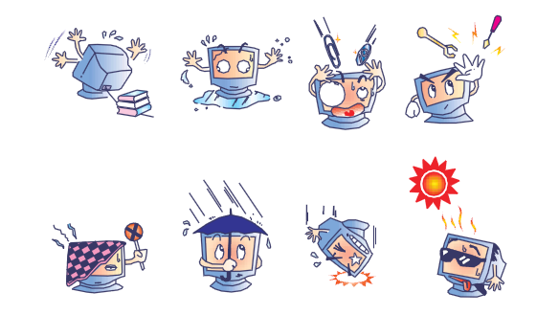
Waste Electrical & Electronic Equipment Directive (WEEE)
 | This product should not be disposed of with household waste. It should be deposited at a facility that enables recovery and recycling.
Chapter 7 – Regulatory Information
I. Electrical Safety Information:
Compliance is required with respect to the voltage, frequency, and current requirements indicated on the manufacturer’s label. Connection to a different power source than those specified herein will likely result in improper operation, damage to the equipment or pose a fire hazard if the limitations are not followed.
There are no operator serviceable parts inside this equipment. There are hazardous voltages generated by this equipment which constitute a safety hazard. Service should be provided only by a qualified service technician.
Contact a qualified electrician or the manufacturer if there are questions about the installation prior to connecting the equipment to mains power.

II. Emissions and Immunity Information
Notice to Users in the United States: This equipment has been tested and found to comply with the limits for a Class B digital device, pursuant to Part 15 of FCC Rules. These limits are designed to provide reasonable protection against harmful interference in a residential installation. This equipment generates, uses, and can radiate radio frequency energy, and if not installed and used in accordance with the instructions, may cause harmful interference to radio communications.
Notice to Users in Canada: This equipment complies with the Class B limits for radio noise emissions from digital apparatus as established by the Radio Interference Regulations of Industrial Canada.
Notice to Users in the European Union: Use only the provided power cords and interconnecting cabling provided with the equipment. Substitution of provided cords and cabling may compromise electrical safety or CE Mark Certification for emissions or immunity as required by the following standards:
This Information Technology Equipment (ITE) is required to have a CE Mark on the Manufacturer’s label which means that the equipment has been tested to the following Directives and Standards: This equipment has been tested to the requirements for the CE Mark as required by EMC Directive 89/336/EEC as indicated in European Standard EN 55022 Class B and the Low Voltage Directive 73/23/EEC as indicated in European Standard EN 60950.
General Information to all Users: This equipment generates, uses and can radiate radio frequency energy. If not installed and used according to this manual the equipment may cause interference with radio and television communications. There is, however, no guarantee that interference will not occur in any particular installation due to site-specific factors.
1) In order to meet emission and immunity requirements, the user must observe the following:
a) Use only the provided I/O cables to connect this digital device with any computer.
b) To ensure compliance, use only the provided manufacturer’s approved line cord.
c) The user is cautioned that changes or modifications to the equipment not expressly approved by the party responsible for compliance could void the user’s authority to operate the equipment.
2) If this equipment appears to cause interference with radio or television reception, or any other device:
a) Verify as an emission source by turning the equipment off and on.
If you determine that this equipment is causing the interference, try to correct the interference by using one or more of the following measures:
i) Move the digital device away from the affected receiver.
ii) Reposition (turn) the digital device with respect to the affected receiver.
iii) Reorient the affected receiver’s antenna.
iv) Plug the digital device into a different AC outlet so the digital device and the receiver are on different branch circuits.
v) Disconnect and remove any I/O cables that the digital device does not use.(Unterminated I/O cables are a potential source of high RF emission levels.)
vi) Plug the digital device into only a grounded outlet receptacle. Do not use AC adapter plugs. (Removing or cutting the line cord ground may in crease RF emission levels and may also present a lethal shock hazard to the user.)
If you need additional help, consult your dealer, manufacturer, or an experienced radio or television technician.

III. Agency Certifications
The following certifications and marks have been issued or declared for this monitor:
Australia C-Tick
Canada CUL, IC
Europe CE
Japan VCCI
Mexico NOM CoC
United States FCC, UL

IV. China RoHS
In accordance to Chinese law (Administration on the Control of Pollution Caused by Electronic Information Products), the section below lists out the name and amount of the toxic and/or hazardous materials that this product may contain.
Component Name | Toxic or Hazardous Substances and Elements
Component Name | Lead(Pb) | Mercury(Hg) | Cadmium(Cd) | Hexavalent  Chromium (Cr6+) | Polybrominated  Biphenyls (PBB) | Polybrominated Diphenyl  Ethers (PBDE)
Plastic Parts | O | O | O | O | O | O
Metal Parts | X | O | O | O | O | O
Wire and Cable Assembly | X | O | O | O | O | O
LCD Panel | X | O | O | O | O | O
Touch Screen Panel | X | O | O | O | O | O
PCBA | X | O | O | O | O | O
Software (CD, etc.) | O | O | O | O | O | O
O: Indicates that this toxic or hazardous substance contained in all of the homogeneous materials for this component is below the limit requirement in SJ/T11363-2006.
X: Indicates that this toxic or hazardous substance contained in at least one of the homogeneous materials used for this component is above the limit requirement in SJ/T11363-2006. For items marked with X, exemptions were taken according to EU RoHS.

Explanation of Markings
(1). In accordance with the SJ/T11364-2006 requirement, the electronic information products are marked with the following pollution control logo. The Environment-Friendly Use Period for this product is 10 years. The product will not leak or mutate under normal operating conditions listed below, so that the use of this electronic information product will not result in any severe environmental pollution, any bodily injury, or damage to any assets.
Operating Temperature:0-40 / Humidity:20%-80% (non-condensing).
Storage Temperature:-20~60 / Humidity:10%~90% (non-condensing).

(2). It is encouraged and recommended that this product be recycled and reused according to local laws. The product should not be thrown away casually.


V. Monitor Specifications
Electrical Ratings:
Input: 5VDC, 1A
Operating Conditions:
Temperature: 0°C - 40°C
Humidity: 20% to 80% (non-condensing)
Altitude: 0 to 3,658m
Storage Conditions:
Temperature: -20°C - 60°C
Humidity: 10% to 90% (non-condensing)
Altitude: 0 to 12,192m
Chapter 8 – Warranty Information

Except as otherwise stated herein, or in an order acknowledgment delivered to Buyer, Seller warrants to Buyer that the Product shall be free of defects in materials and workmanship. The warranty for the TouchMonitors, Computer Module, and their components is 3 (three) years.

Seller makes no warranty regarding the model life of components. Seller’s suppliers may at any time and from time to time make changes in the components delivered as Products or components.

Buyer shall notify Seller in writing promptly (and in no case later than thirty days after discovery) of the failure of any Product to conform to the warranty set forth above; shall describe in commercially reasonable detail in such notice the symptoms associated with such failure; and shall provide to Seller the opportunity to inspect such Products as installed, if possible. The notice must be received by Seller during the Warranty Period for such product, unless otherwise directed in writing by the Seller. Within thirty days after submitting such notice, Buyer shall package the allegedly defective Product in its original shipping carton(s) or a functional equivalent and shall ship to Seller at Buyer’s expense and risk.

Within a reasonable time after receipt of the allegedly defective Product and verification by Seller that the Product fails to meet the warranty set forth above, Seller shall correct such failure by, at Seller’s options, either (i) modifying or repairing the Product or (ii) replacing the Product. Such modification, repair, or replacement and the return shipment of the Product with minimum insurance to Buyer shall be at Seller’s expense. Buyer shall bear the risk of loss or damage in transit, and may insure the Product. Buyer shall reimburse Seller for transportation cost incurred for Product returned but not found by Seller to be defective. Modification or repair, of Products may, at Seller’s option, take place either at Seller’s facilities or at Buyer’s premises. If Seller is unable to modify, repair, or replace a Product to conform to the warranty set forth above, then Seller shall, at Seller’s option, either refund to Buyer or credit to Buyer’s account the purchase price of the Product less depreciation calculated on a straight-line basis over Seller’s stated Warranty Period.

These remedies shall be the buyer’s exclusive remedies for breach of warranty. Except for the express warranty set forth above, seller grants no other warranties, express or implied by statute or otherwise, regarding the products, their fitness for any purpose, their quality, their merchantability, their non-infringement, or otherwise. No employee of Seller or any other party is authorized to make any warranty for the goods other than the warranty set forth herein. Seller’s liability under the warranty shall be limited to a refund of the purchase price of the product. In no event shall Seller be liable for the cost of procurement or installation of substitute goods by Buyer or for any special, consequential, indirect, or incidental damages.

Buyer assumes the risk and agrees to indemnify Seller against and hold Seller harmless from all liability relating to (i) assessing the suitability for Buyer’s intended use of the Products and of any system design or drawing and (ii) determining the compliance of Buyer’s use of the Products with applicable laws, regulations, codes, and standards. Buyer retains and accepts full responsibility for all warranty and other claims relating to or arising from Buyer’s products, which include or incorporate Products or components manufactured or supplied by Seller. Buyer is solely responsible for any and all representations and warranties regarding the Products made or authorized by Buyer. Buyer will indemnify Seller and hold Seller harmless from any liability, claims, loss, cost, or expenses (including reasonable attorney’s fees) attributable to Buyer’s products or representations or warranties concerning same.
Check out Our Website!

www.elotouch.com

Get the latest...

- Product Information
- Specifications
- Upcoming events
- Press releases
- Software drivers

Getting in Touch with us

To find out more about the extensive range of Elo touch solutions, visit our website at
www.elotouch.com, or simply call the office nearest you:

North America  Elo Touch Solutions  1033 McCarthy Blvd  Milpitas, CA 95035 | Latin America  Tel 786-923-0251  Fax 305-931-0124  www.elotouch.com.ar  Asia-Pacific  Tel +81 (45) 478 2161  Fax +81 (45) 478 2180  www.tps.co.jp  Europe  Tel +32 (0) 16 70 45 00  Fax +32 (0)16 70 45 49  elosales@elotouch.com  Tel 800-ELO-TOUCH  Tel + 1 408 597 8000  Fax +1 408 597 8050  customerservice@elotouch.com

Copyright 2015 Elo Touch Solutions, Inc. All rights reserved.
Latin America
Tel 786-923-0251
Fax 305-931-0124
www.elotouch.com.ar
Asia-Pacific
Tel +81 (45) 478 2161
Fax +81 (45) 478 2180
www.tps.co.jp
Europe
Tel +32 (0) 16 70 45 00
Fax +32 (0)16 70 45 49
elosales@elotouch.com
Tel 800-ELO-TOUCH
Tel + 1 408 597 8000
Fax +1 408 597 8050
customerservice@elotouch.com
Latin America
Tel 786-923-0251
Fax 305-931-0124
www.elotouch.com.ar
Asia-Pacific
Tel +81 (45) 478 2161
Fax +81 (45) 478 2180
www.tps.co.jp
Europe
Tel +32 (0) 16 70 45 00
Fax +32 (0)16 70 45 49
elosales@elotouch.com
Tel 800-ELO-TOUCH
Tel + 1 408 597 8000
Fax +1 408 597 8050
customerservice@elotouch.com

